|  |  |  |
| --- | --- | --- |
| **Nama** | : | Muhamad Al Kausar Ramadhan |
| **Nim** | : | 2041720193 |
| **Kelas** | : | TI 3A |

**PRATIKUM 1**

1. activity_main.xml

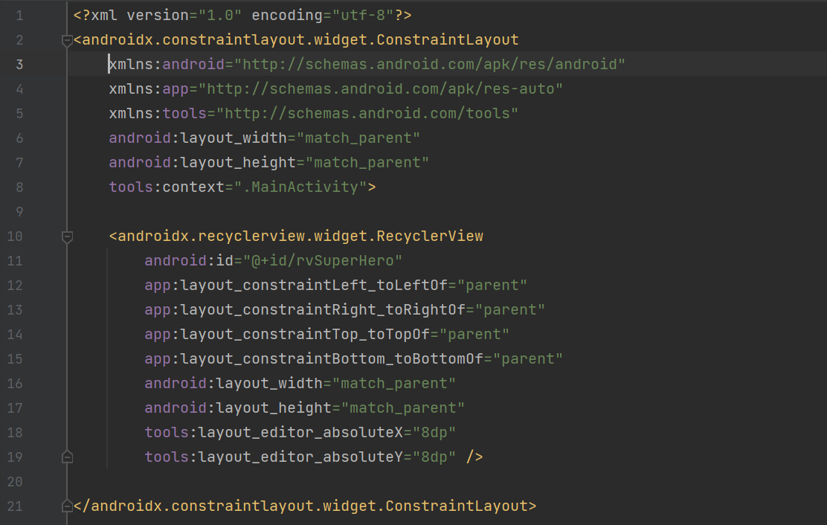

1. item_super_hero.xml

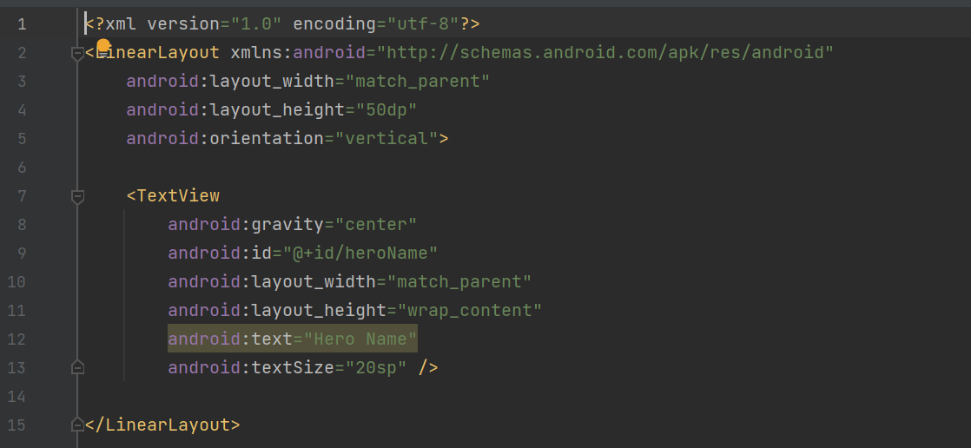

1. models/SuperHero.java

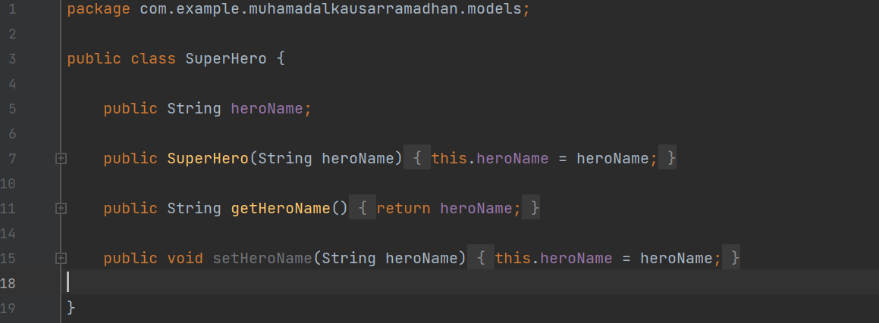

1. adapters/SuperHeroAdapters.java

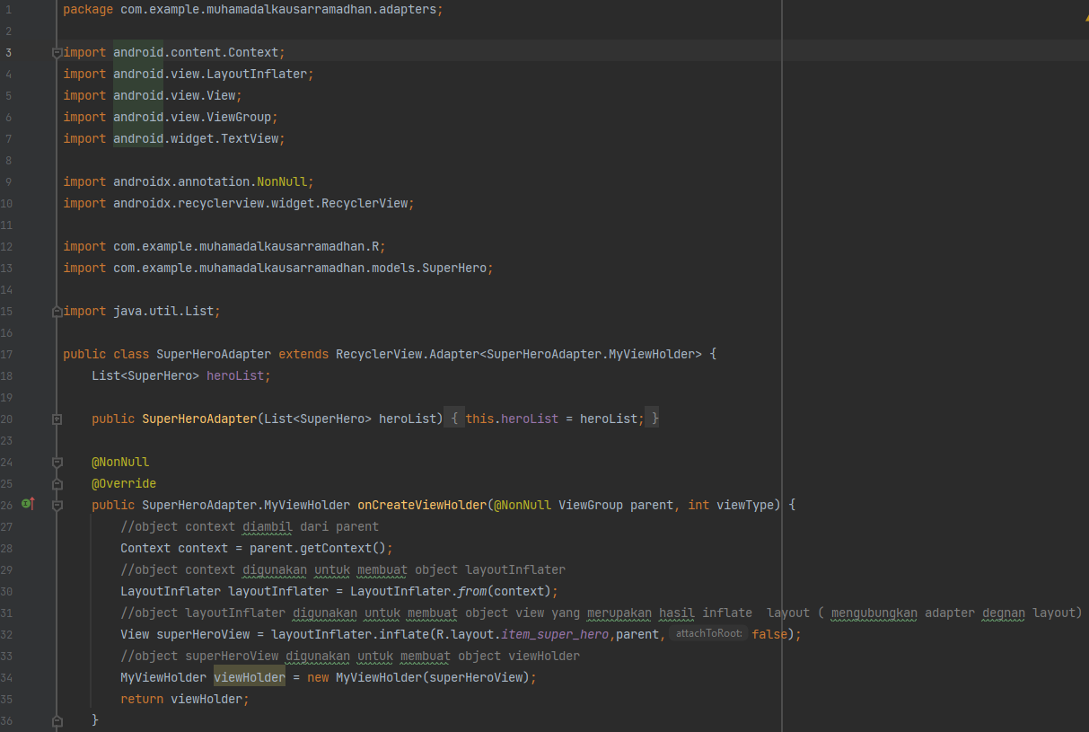

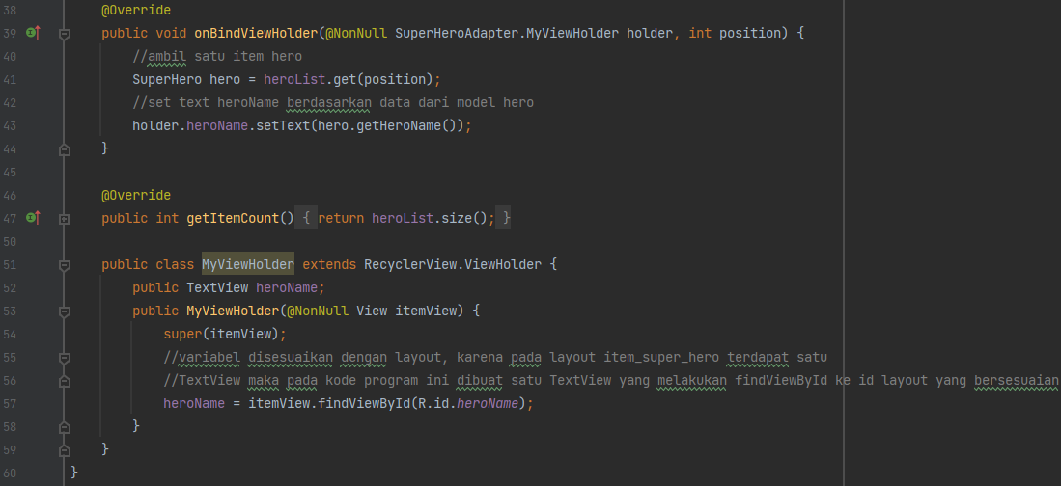

1. MainActivity.java

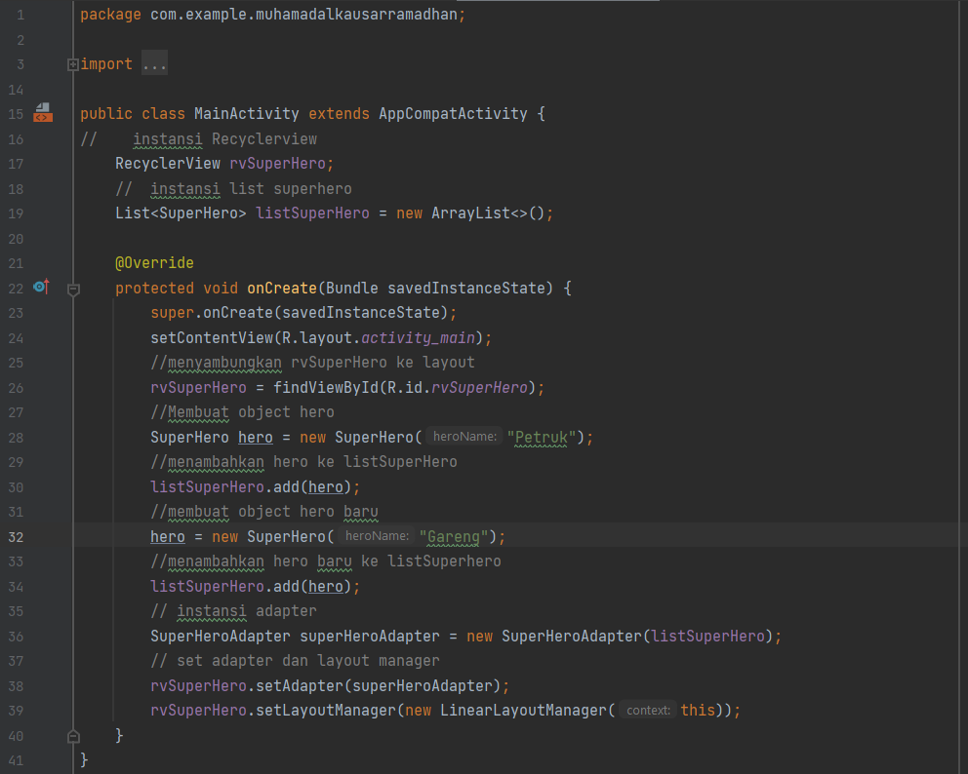

1. Tampilan

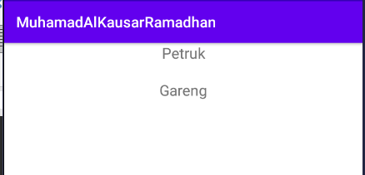

1. Gradle

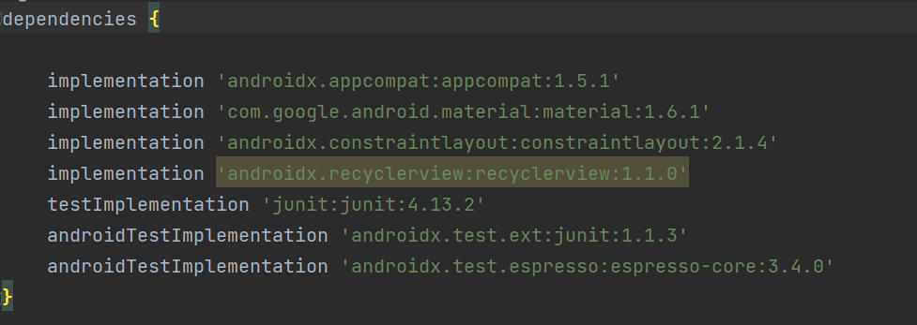

**PRATIKUM 2**

1. activity_main.xml

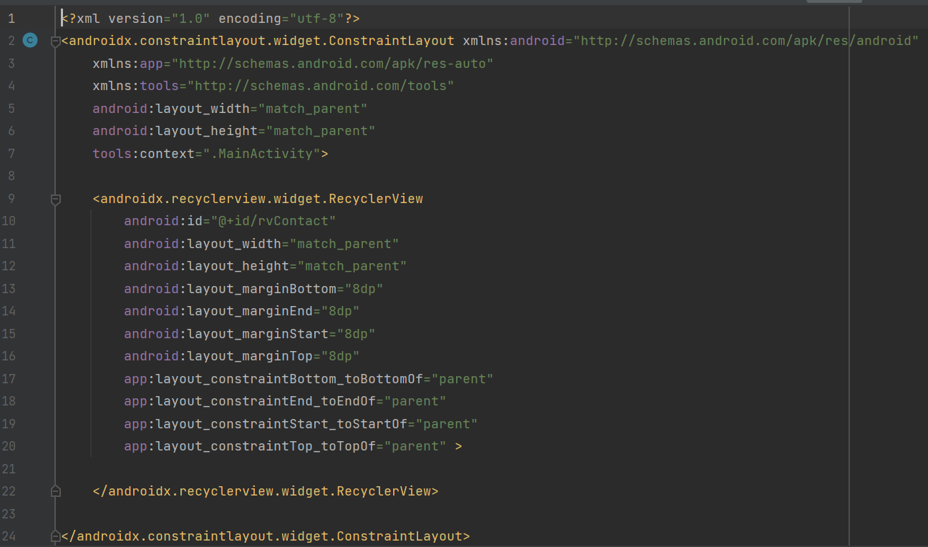

1. item_contact.xml

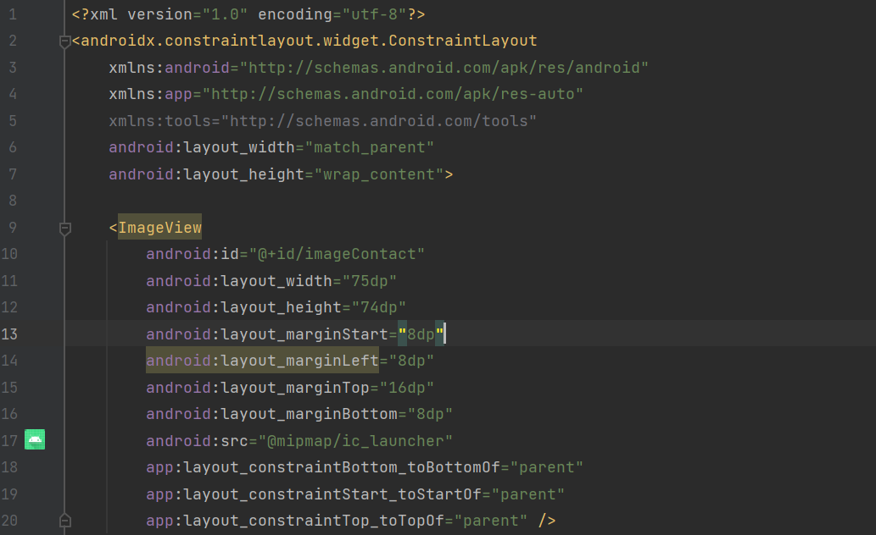

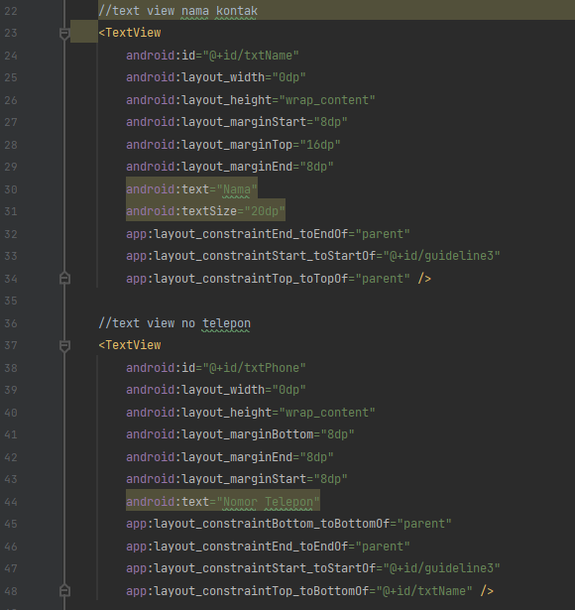

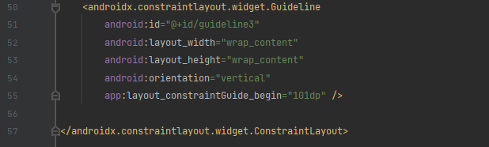

1. Contact.java

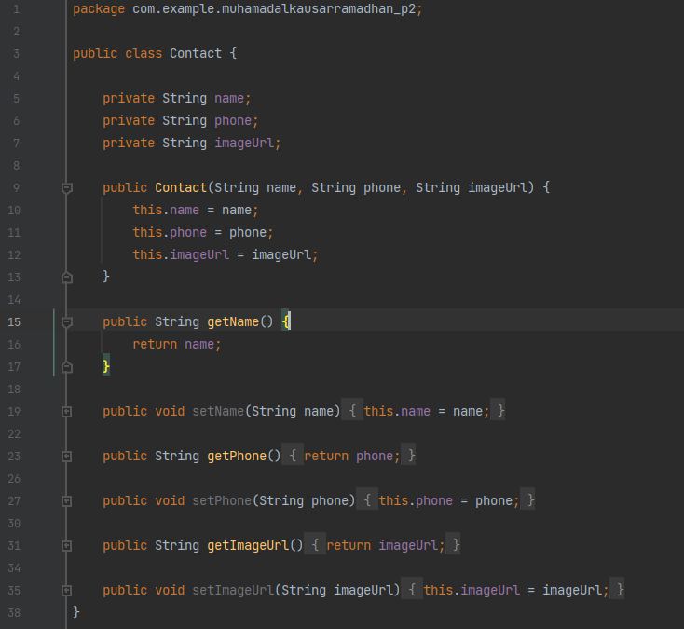

1. ContactAdapter.java

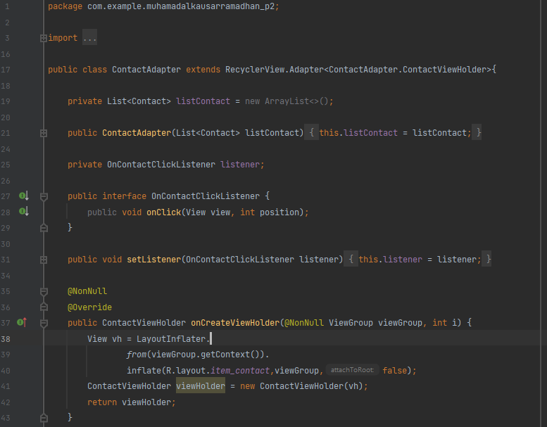

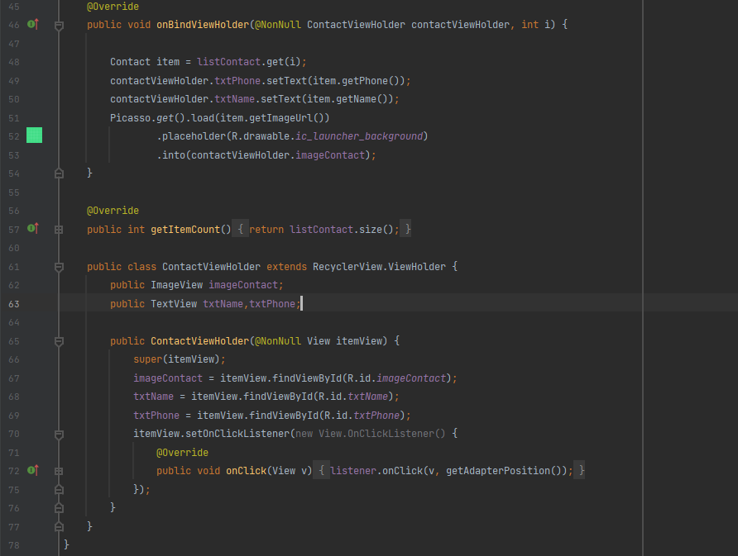

1. MainActivity.java

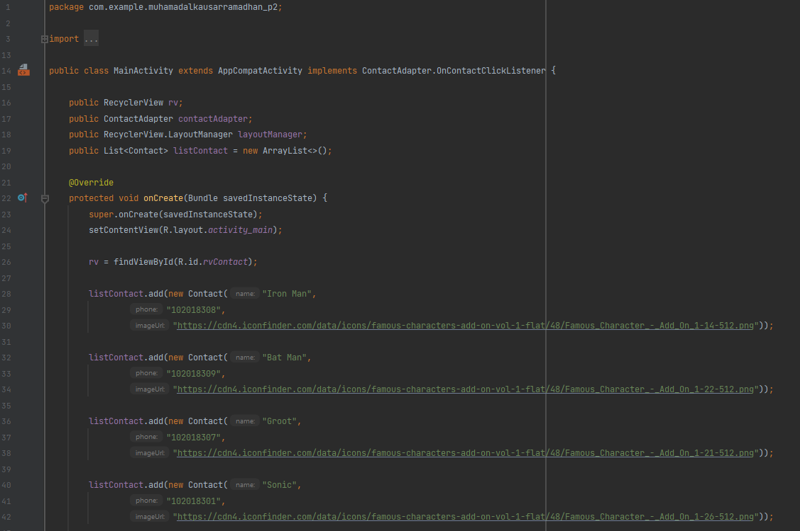

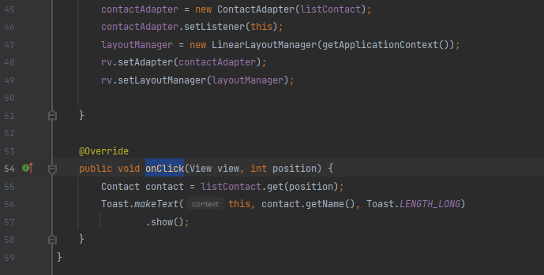

1. Tampilan

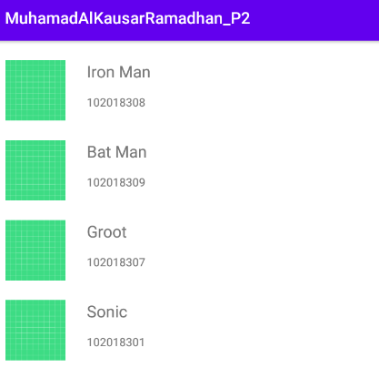

1. Gradle

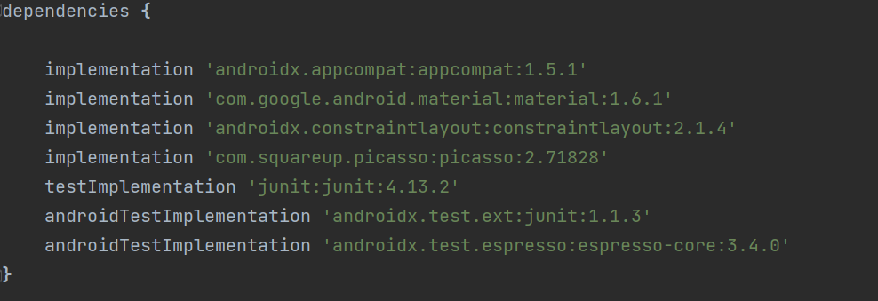

**LINK GITHUB**

[**https://github.com/kausar-vento/tugas-pembelajaran-mesin-minggu4.git**](https://github.com/kausar-vento/tugas-pembelajaran-mesin-minggu4.git)